Final Demo

0710028 陳敬諺

Previous plan review:

this project will compare the prize of the game that the user wants to buy on several online store (Steam and Amazon), then, telling the user which one is the cheapest one. Furthermore, if the user wants to know about the game, the project can show the user the details of the game, including age rating, hardware requirement, reviews, trailers, etc.

Update 1 review:

I have typed rough structure of my project. I have confirmed that applying of youtube api is working. Next step, I will let my application being able to show the website of the trailer of the game. Besides, I have proved that web crawler is useful on game critic forum (IGN.com); then, I will find out the part of the review of the game. Moreover, because Steam store api key didn’t work, I need to find the way that I can get the information from Steam webpage and find the other api key to fit the requirement of final project.

Update 2:

I decide to cancel the function about watching review from IGN because I found that the homepage of IGN is able to be crawled while it isn’t accessible to the page of review of game. And I cannot find the proper store webpage to get the price of the game to compare; thus, I only show the price on Steam. I use crawler on Steam to get the price of game and the name of game’s publisher. Then, I choose to use the google map api to search the profile of the publisher. Finally, I use tkinter to create the GUI.

Run:

The libraries requirement:

import tkinter as tk

from tkinter import ttk

import urllib.request,urllib.parse,urllib.error

import json

from bs4 import BeautifulSoup

step1: execute the program

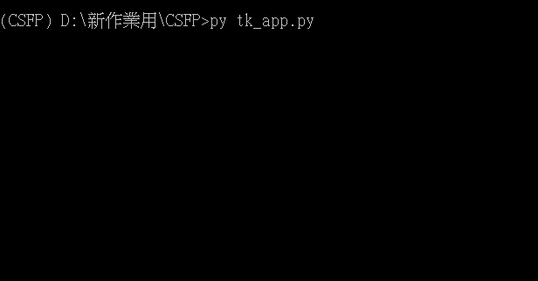

Then GUI will show up.

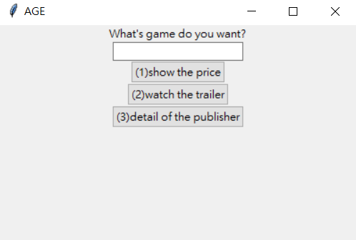

Step2: type the name of game in Entry block then click function button

Example 1: show the price

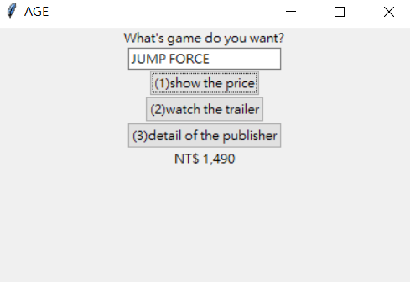

Example 2: watch the trailer

It will show the user the title of trailer on youtube and its website.

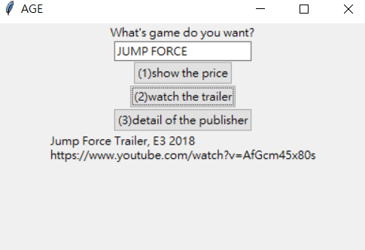

(Note: Actually, I should use hyper link on website but I cannot find out the mistake that I type in program. Thus, I determine not to use this function temporarily.)

Example 3: detail of the publisher

It will show the publisher name and the address of company and phone number.

